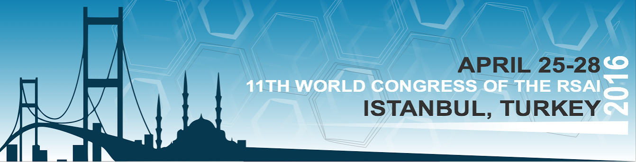

Call for papers - Special Session on [insert the main theme of the special session]

We are pleased to invite you to contribute papers for a Special Session on [insert the main theme of the special session], which we will organize at the 11th RSAI World Congress on April 25-28, 2016. The RSAI World Congress will take place in in Istanbul (Turkey) and will be a major international event.

Motivation and aim
[Insert motivation and aim]

Potential topics:
[Insert topics]

Session Organizers
[Name (Institution, Country)]
[Name (Institution, Country)]
....

Submitting an abstract
Please submit an abstract (400-500 words) indicating title; authors(s), affiliations and emails (indicate the corresponding author); three keywords; and two potential topics to the session Organizers, by sending an e-mail to [insert email] or [insert email].

Abstract submission deadline: November 29, 2015
Notification of acceptance of abstract: December 20, 2015
Details about the Conference: http://2016worldcongress.regionalscience.org/

