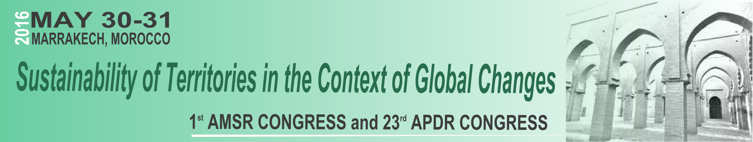 Special Session Proposal
Title:
The name(s) of the organizer(s), with affiliation(s) and email(s) (identifying the chair)
Aim and scope of the session (100 words):

