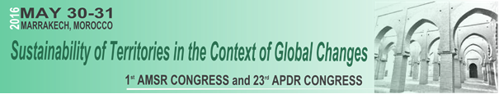

Call for papers - Special Session on [insert the main theme of the special session]

We are pleased to invite you to contribute papers for a Special Session on [insert the main theme of the special session], which we will organize at the 1st AMRS Congress and 23rd APDR Congress with the theme Sustainability of Territories in the Context of Global Changes on 30-31 May 2016. The Congress will take place in Marrakech, Morocco and will be a major international event.

Motivation and aim
[Insert motivation and aim]

Potential topics:
[Insert topics]

Session Organizers
[Name (Institution, Country - email)]
[Name (Institution, Country - email)]
....

Submitting an abstract
Please submit an abstract (max. 400 words) indicating title; authors(s), affiliations and emails (indicate the corresponding author); three keywords; and two potential topics to the session Organizers, by sending an e-mail to [insert email] or [insert email].

Abstract submission deadline: April 10, 2016
Notification of acceptance of abstract: April 20, 2016

Details about the Conference: http://www.apdr.pt/congresso/2016/

