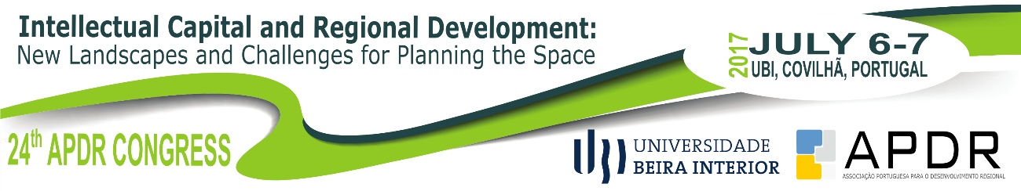

Call for papers - Special Session on [insert the main theme of the special session]

We are pleased to invite you to contribute papers for a Special Session on [insert the main theme of the special session], which we will organize at the 24th APDR Congress with the theme Intellectual Capital and Regional Development: New landscapes and challenges for space planning on 6-7 July 2017. The Congress will take place in Covilhã, University of Beira Interior, POLO III (building of the Faculdade de Ciências da Saúde) and will be a major international event.

Motivation and aim
[Insert motivation and aim]

Potential topics:
[Insert topics]

Session Organizers
[Name (Institution, Country - email)]
[Name (Institution, Country - email)]
....

Submitting an abstract
Please submit an abstract (max. 400 words) indicating title; authors(s), affiliations and emails (indicate the corresponding author); three keywords; and two potential topics to the session Organizers, by sending an e-mail to [insert email] or [insert email].

Abstract submission deadline: April 28, 2017
Notification of acceptance of abstract: May 12, 2017

Details about the Conference: http://www.apdr.pt/congresso/2017/

